Individual Contribution and Project Management Report
1. Individual Contributions and Roles
During the development of the Recruitment System (JRS), I held a dual role: serving as the Lead UI/UX Designer for core HR workflows while also acting as the Project Manager to ensure team cohesion and timely delivery.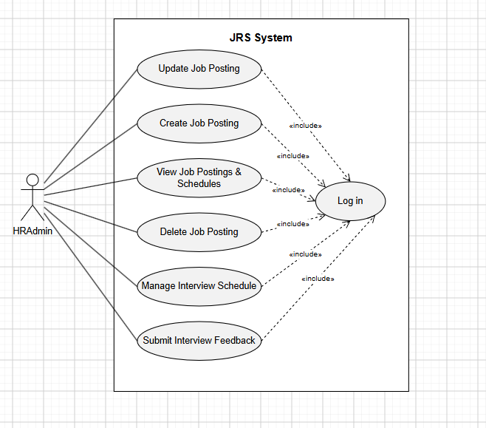
My primary technical contribution was the end-to-end design of the job posting and interview management modules—components that form the foundation of the system's value proposition. I held full responsibility for the conceptualization, wireframing, and high-fidelity prototyping of the following five key interfaces, the results of which are fully reflected in the project deliverables:

- Interfaces for creating and editing job postings: I carefully designed these two key forms to balance comprehensive data collection with a clean, intuitive user experience. I organized the layout into logical modules—covering basic information (job title, department, location, employment type, and salary range), scheduling (deadlines, publication dates, and unpublishing dates), and a rich-text area for job descriptions and requirements. The "Edit Job" page seamlessly populates existing data, while the "Create New Job" page emphasizes clear action prompts, such as "Save Draft" and "Publish Job."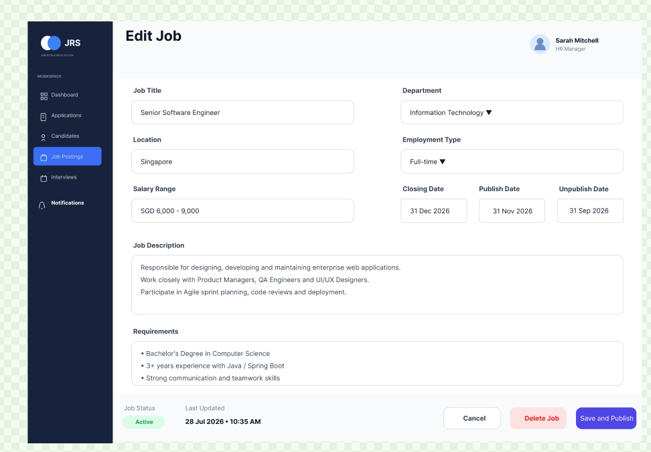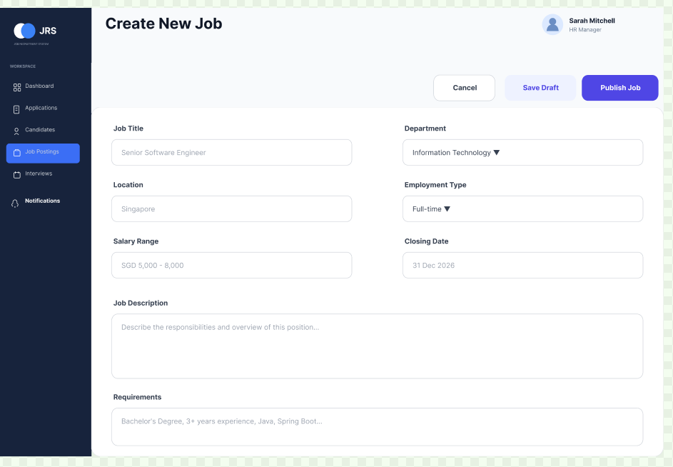
- Interview Schedule: To facilitate the hiring pipeline, I designed an "Upcoming Interviews" tracking screen. This interface provides a clear chronological view of interviews, distinguishing between "Online" and "On-site" types (e.g., linking specific locations like "A01" or "B04" to candidates like Jane Doe and Alex Tan).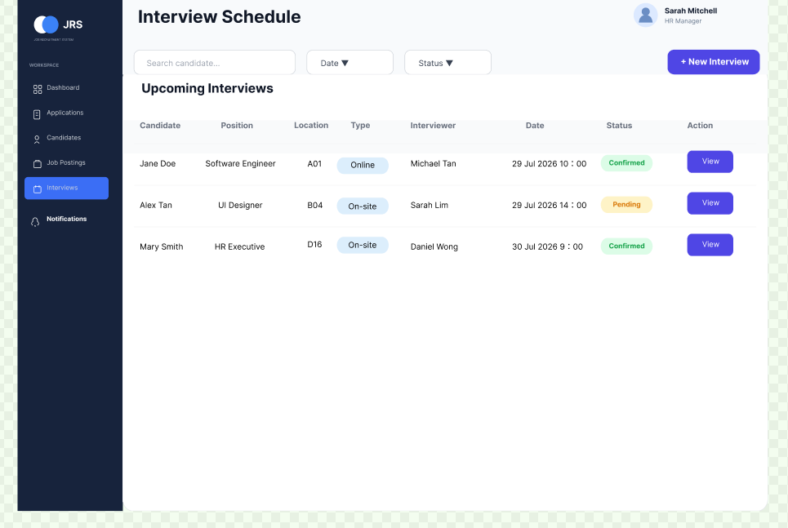
- Interview Feedback Form: I am very pleased with this evaluation interface. I designed a structured assessment matrix that uses a five-star rating system to evaluate competencies (experience, technical skills, communication, and teamwork). Additionally, I included a section for detailed technical notes and a radio button for an overall recommendation (Hire, Reject, or Further Consideration) to ensure standardized candidate evaluation.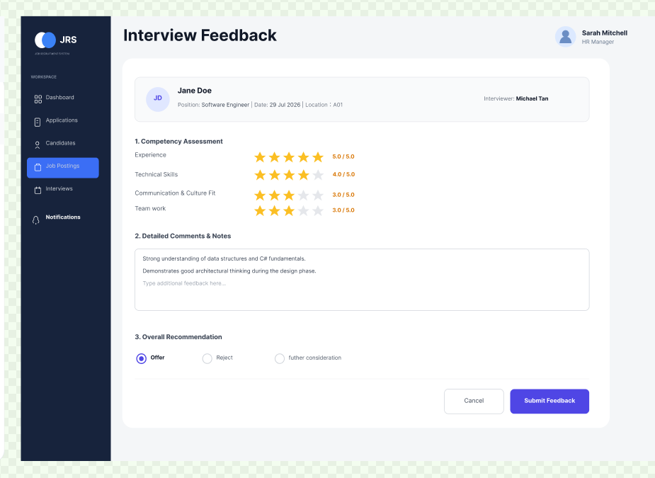

Frontend Development & Code Implementation：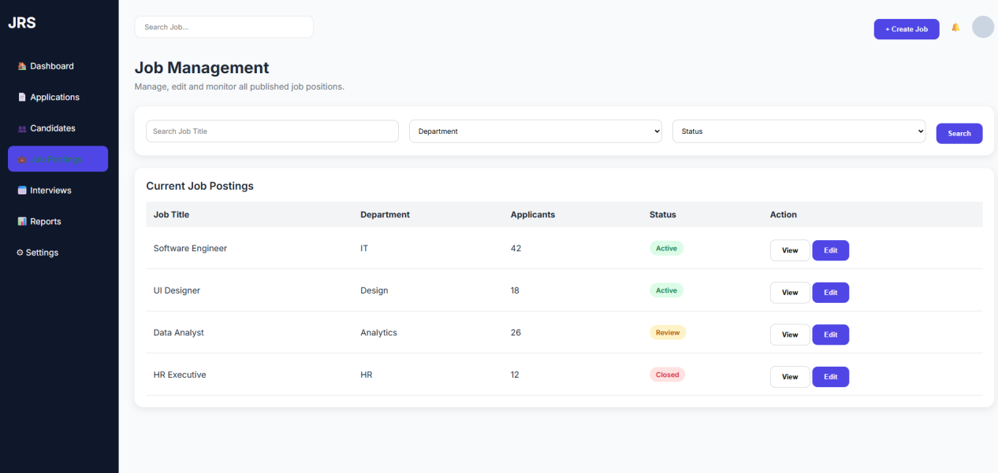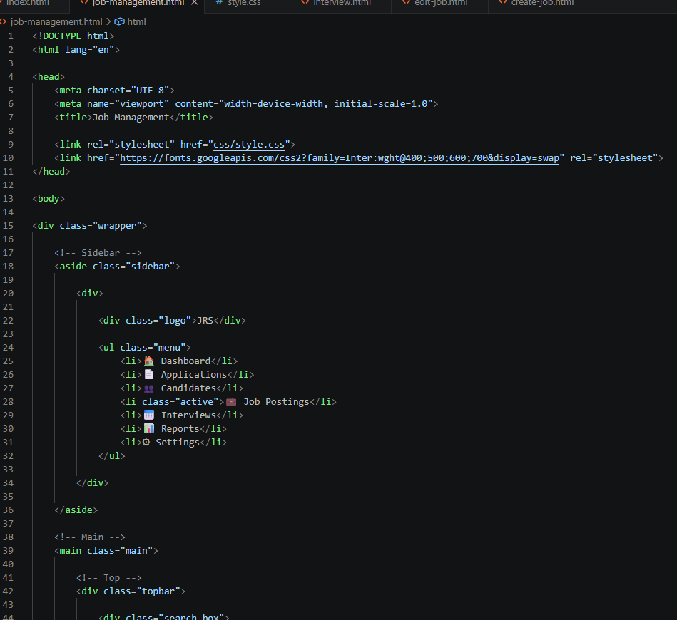
Beyond the primary modules I was responsible for, I contributed to approximately 30% of the frontend's overall consistency by helping team members align their components—such as navigation sidebars and notification dropdowns—with the established design system. As a project manager, my responsibilities included defining iteration scopes, setting internal deadlines, tracking cross-functional dependencies, and providing assistance when team members encountered technical or design challenges.
2. Self-Directed Learning
Successfully delivering these designs required extensive self-directed learning, covering both design execution and underlying software architecture. Before drafting any interfaces in Figma, I conducted in-depth research into system analysis and Unified Modeling Language (UML) structures. I dedicated significant time to independently studying use-case naming conventions, identifying key system actors, and mapping out complex activity diagrams. This theoretical foundation was crucial; it ensured that the HR workflows I translated into Figma were logically sound, user-centric, and technically feasible.
Furthermore, I needed to enhance my UI/UX design skills. I taught myself how to leverage Figma’s advanced features—such as Auto Layout and interactive components—to create scalable, responsive form fields and data tables. I also researched industry-standard HR practices to ensure that the fields I implemented (such as the specific distinction between publication and un-publication dates) accurately reflected real-world recruitment requirements.
Looking ahead to the second phase of this project, my self-study focus will shift from visual design to technical implementation. I plan to engage in extensive independent study to deepen my mastery of the C# programming language. Given the system's requirement for robust data processing capabilities—underscored by the emphasis on C# fundamentals noted in my interview feedback—I intend to independently study advanced object-oriented programming patterns, database integration, and API development. This will enable me to effectively build the backend logic required to support the CRUD operations I have designed.
3. Project Management Tools and Timeliness
Strict application of project management tools is essential to ensure all activities are completed on schedule. I advocate for using centralized Kanban boards (such as Trello or Jira) to break down high-level project requirements into actionable, trackable tasks.
By categorizing tasks into "To-Do," "In Progress," "Under Review," and "Completed," I maintain full visibility over project status. We utilize Gantt charts to map out dependencies—for instance, ensuring the database schema is finalized before high-fidelity form designs are completed. These tools directly contribute to successful project outcomes by effectively preventing scope creep and ensuring that each module is not only delivered on time but also allows sufficient time for integration testing.
4. Meeting Attendance and Participation
Communication is the cornerstone of our project's progress. I attend formal bi-weekly meetings with the project lead without fail. During these sessions, I actively participate by reporting on progress—specifically by demonstrating interactive Figma prototypes—to gather early feedback on user flows.
Internally, I organize weekly sync-up meetings with my colleagues. I play an active role in these discussions, frequently proposing ideas for system architecture and UI improvements while carefully considering constraints raised by backend developers to ensure my designs are feasible. When technical conflicts arise, I facilitate discussions to reach a consensus, ensuring everyone's input is heard and the project continues to move forward.
5. Team Interaction and Quality of Deliverables
My interactions with team members are consistently collaborative, respectful, and highly professional. Recognizing that design is the initial step in the development process, I prioritize avoiding any potential bottlenecks in the workflow.
I make it a practice to deliver tasks ahead of schedule. For instance, the complete Figma prototypes for the job posting and interview modules were handed over to the development team days before the internal milestone deadline. This proactive approach is intentional; it allows ample time for peer reviews, constructive feedback, and necessary revisions. This enables developers to review layouts and propose specific state changes—such as error validation or hover states—without the pressure of looming deadlines. Consequently, my deliverables are of high quality, thoroughly vetted, and ready for seamless technical integration.

